More resources from the Alameda Dyslexia Community are located on Alameda’s website:

<https://www.pps.net/domain/4429>.

**References:**

PDX Reading Specialists. (n.d.). Retrieved from <http://www.pdxreadingspecialist.com/>.

Understood.org. (2017). Retrieved from <https://www.understood.org>.

Decoding Dyslexia Oregon. (2017). Retrieved from <http://www.decodingdyslexiaor.org/>

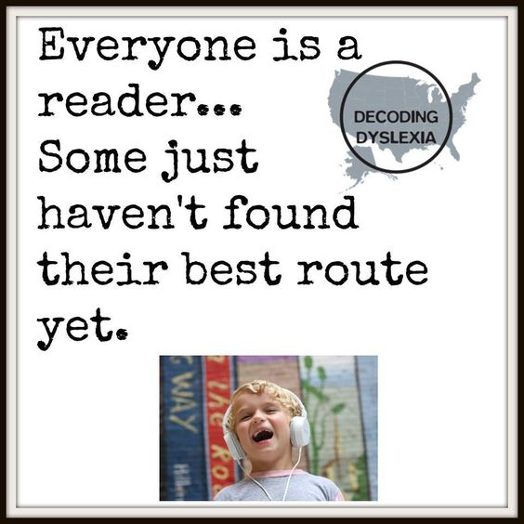

Dyslexia Book List

for Students and Parents

Compiled by:

Alameda Dyslexia Community

2017

***Author’s with Dyslexia:***

* Agatha Christie
* Avi — The Crispin series, Nothing But the Truth, and many more titles.
* Dav Pilkey — Captain Underpants, Ricky Ricotta, and more.
* F. Scott Fitzgerald
* Henry Winkler – Hank Zipzer Series
* Jay Leno
* Jeanne Betancourt — My Name Is Brain Brian, Pony Pals Series, and more.
* John Irving – The World According to Garp
* L.J Kidd
* Patricia Polacco — Thank You, Mr. Falker, The Blessing Cup, and more.
* Sally Gardner - Magical Kids Series, Operation Bunny Series, and more.
* Stacey R. Campbell — Arrgh!
* Tom McLaughlin — The Cloudspotter, The Story Machine, and more
* Victor Villasenor Burro – Genius; Rain of Gold

***Books for Parents***

* *Essentials of Assessment and Intervention* by Nancy Mather & Barbara Wendling; John Wiley
* *It’s So Much Work to Be Your Friend: Helping the Child with Learning Disabilities Find Social Success* by Rihard Lovoie
* *Overcoming Dyslexia* by Shelly Shaywitz
* *Proust and the Squid* by Maryanne Wolf
* *Parenting a Struggling Reader* by Susan L. Hall and Louisa C. Moats
* *The Dyslexic Advantage* by Brock L. Eide and Fernette F. Eide
* *The Dyslexia Empowerment Plan* by Ben Foss
* *The Gift of Dyslexia* by Ronald D. Davis
* *Wrightslaw: From Emotions to Advocacy: The Special Education Survival Guide* by Pam Wright and Pete Wright
* *Understanding Dyslexia and Other Learning Disabilities* by Linda Siegel
* *Author: A True Story* by Helen Lester

***Books for Students***

* *Back to Front and Upside Down!* by Claire Alexander
* *Best Kept Secret: The Third Generation* by Ann M. Martin
* *Bluefish* by Pat Schmatz
* *Caged in Chaos: A Dyspraxic Guide to Breaking Free* by Victoria Biggs
* *Close to Famous* by Joan Bauer
* *Counting to D* by Kate Scott
* *Dyslexia Wonders: Understanding the Daily Life of a Dyslexic from a Child's Point of View* by Jennifer Smith
* *Eleven* by Patricia Reilly Giff
* *Fish in a Tree* by Lynda Mullaly Hunt
* *Free Association: Where My Mind Goes During Science Class* by Barbara Esham
* *Hank Zipzer: The World’s Greatest Underachiever* (series) by Henry Winkler and Lin Oliver
* *I Know Someone With Dyslexia* by Sue Barraclough
* *If You're So Smart, How Come You Can't Spell Mississippi?* by Barbara Esham
* *It’s Called Dyslexia* by Jennifer Moore
* *Last to Finish: A Story About the Smartest Boy in Math Class* by Barbara Esham
* *Lily and the Mixed-up Letters* by Deborah Hodge
* *Mrs. Gorski, I think I Have the Wiggle Fidgets* by Barbara Esham
* *My Friend Has Dyslexia* by Amanda Tourville
* *My Name is Brain* by Jeanne Betancourt
* *Stacey Coolidge’s Fancy-Smancy Cursive Handwriting* by Barbara Esham
* *Tacky the Penguin* by Helen Lester
* *Thank you, Mr. Faulker* by Patricia Pollacco
* *The Alphabet War: A Story About Dyslexia* by Diane Burton Robb and Gail Piazza
* *The Boy Who Learned Upside Down: Based on a True Story* by Christy Scattarella
* *The Don't-Give-Up Kid: Learning Disabilities* by Jeanne Gehret
* *The Human Side of Dyslexia: 142 Interviews with Real People Telling Real Stories About Their Coping Strategies with Dyslexia* by Shirley Kurnoff
* *The Lightning Thief* and others in the series by Rick Riordan
* *The Vicar of Nibbleswick* by Roald Dahl
* *The Wild Book* by Margarita Engle
* *Tom's Special Talent* by Kate Gaynor
* *Trapped* by Judy Spurr
* *Two-Minute Drill: Mike Lupica’s Amazing Comeback Kids* by Mike Lupica
* *What is Dyslexia? A Book Explaining Dyslexia for Kids and Adults to Use Together* by Alan M. Hultquist
* *My Thirteenth Winter: A Memoir* by Samantha Abeel