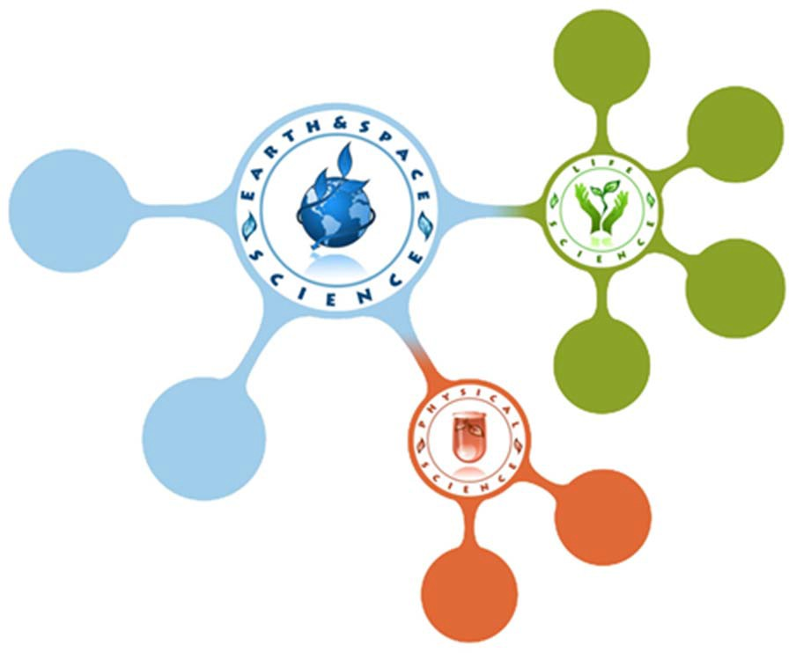**Welcome to the PPS Mid-Level Science Kits Program!**

***Contact Us***

**Receiving Your New Science Kit Ready to Go!**

Identifying your kit:

1. The label on the front of your kit identifies the content and the units that you will be teaching. The kit modules are as follows: 6L, 6P & 6E= 6th Grade, P1, P2 & P3=7th Grade, and E1, E2 & E3= 8th Grade. The units are identified by letters. You will also find the number of totes that complete your kit e.g. (Box 1 of 1 or 2 of 2).

How to unpack your kit:

1. Remove the drawers from inside of your kit and place them inside of your cart.

2. **PLEASE KEEP** all lids that arrive with your kit. They will be reused when repacking your kit to secure the contents inside during transportation back to the BESC.

3. Keep your empty totes in a safe/secure location along with your lids to insure they will not get lost or damaged.

**Repacking & Returning Your Kit**

1. Inside of your kit you will find a booklet with a complete materials guide list of items in each drawer. Before returning your kit, these items need to be properly placed back into their specified drawer and compartment.

2. All drawers must be placed back into their assigned tote. You will find which drawers belong to which tote by reading the label on the front of your kit.

3. Place the cardboard lids back onto the tops of the drawers in each tote before closing.

Next use the yellow zip ties attached to the top of your totes and secure tightly before transportation. **DO NOT** send kits back without zip ties.

**Pick up & Delivery Schedules**

Kits **MUST** be ready for pickup at their scheduled time! Your school will have a designated bulk delivery site where kits will be picked up. There will be 3

rotations per year. You will be notified prior to pickup

of the exact day this will occur. The delivery schedule is as follows:

|  |  |  |
| --- | --- | --- |
| **Delivery** | **Arrival** | **Pick Up** |
| 1st | September | November |
| 2nd | January | March |
| 3rd | April | June |

If you miss the pickup date, it is important to return your kit as soon as possible to insure that the next teacher can receive a kit*.* Failure to do so impacts another teacher’s classroom time, as well as affecting their students.

**Ordering live materials online**

Access the Multimedia Library from Inside PPS Home Page [http://www-av.pps.k12.or.us](http://www-av.pps.k12.or.us/). At the top of the

Multimedia Library page, click on the green tab labeled “Science Kits”

o Click on the Science Kit Consumable Order Form link to order live materials.

o Other Teachers must be listed if ordering multiple quantities

o Submit request when finished

o Please plan ahead as ordering can take 1-2 weeks